Enhance your ability to integrate the performing arts into your academic classroom by joining the Auditorium Theatre’s ArtsXChange Teacher Professional Development Cohort!
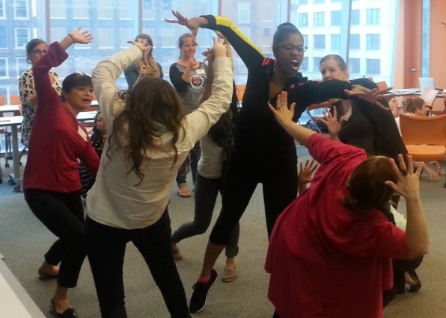

This unique experience pairs classroom teachers with Teaching Artist Mentors for the full school year as they collaborate to design and facilitate fully arts-integrated units that directly connect to three student matinee performances at the historic Auditorium Theatre! Teachers are challenged to engage with their curriculum in new and exciting ways through the power of dance, theatre, and music, and leave the program with concrete skills and activities they can use to continue infusing the performing arts into their teaching practice for years to come! The program, including tickets and transportation to performances, is available at no cost.

What makes an ArtsXChange Teacher?
We are looking for educators with a desire to grow in their practice and an open-minded attitude toward the possibilities of arts learning! You don’t need ANY previous experience with an art form to be an ArtsXChange participant – you just need to be willing to learn and explore alongside your students! Connecting all residency work to your classroom objectives, ArtsXChange will equip you with tools you can use to make arts learning a part of your daily teaching practice.
Note: The primary focus of ArtsXChange is to work with non-art classroom teachers!

Who will I be working with?
We partner all of our classroom teachers with the Auditorium Theatre’s professional music, dance, and theatre Teaching Artist Mentors who have worked to successfully bring arts programming to schools around the city and country. These Teaching Artist Mentors bring their knowledge of best practices in arts integration and aesthetic education to the table as they work with you to create dynamic and rich residency experiences for your students.

What does the program involve?
ArtsXChange is designed for YOU – the educator! Your collaboration with a Teaching Artist Mentor will not only enhance your students’ experience of the three matinee performances they get to attend as a part of your participation in this program, but will allow you to create arts-based learning opportunities that enhance your daily teaching and assessment practices.
- Four hours of summer planning with your Teaching Artist Mentor (July & August)
We know that classroom teachers complete most of their curriculum maps and unit plans during the summer months. We want to allow for you and your Teaching Artist to plan together, interweaving the arts throughout your curriculum. This is a time that you schedule to fit around your summer plans!

- 2020-21 ArtsXChange Cohort Kick-Off (September)
You will have the opportunity to collaborate with other participants in the cohort and learn what ArtsXChange will look like in their classrooms. We will use this time to analyze your classroom data and establish academic goals for your students.

- Six hours of additional planning and reflection time with your teaching team and Teaching Artist Mentor (September-May)
These meetings help ensure that all residency materials are connecting to your current curriculum and truly enhancing your practice. These meetings are when the true work of ArtsXChange happens, as the discussions with your TAM allow you (the educator) to gain understanding and ownership of the arts-based learning in your academic day.

- Three residency periods
Scheduled throughout the school year, a Teaching Artist Mentor will partner with you and your students for five one-hour class periods during the school day.

- Three field trips to see the anchor works of art at Auditorium Theatre
These professional performances are 60 minutes long and occur during the school day, providing you and your students the opportunity to connect the arts concepts and vocabulary being explored in class with professional work. The anchor works provide touch points for arts learning throughout the year.

- Three two-hour out-of-school professional development meetings
Held throughout the year, these evening meetings address your challenges or concerns during residency periods, and provide you with time to more deeply explore the implementation and assessment of arts learning in your classroom. Specific dates and times are announced at the start of the school year, allowing participants plenty of time to plan ahead for attendance.

- One End-of-Year Curriculum Share
At the end of the program year, get together with your cohort to celebrate and share all you have accomplished while working with the program!

We look forward to welcoming you into our ArtsXChange community!

Teacher name:__________________ _

Teacher e-mail address:__________________________________________________________________
Grade level taught: _________ _________________________________________________________

Subject area(s): ________________________________________________________________________

# of years teaching: _______# of years teaching at current school: ___

School ___________________________________________________________________________________

Principal: _______________

Principal Email: _______________

Please be sure to discuss this program with your principal!
ArtsXChange is a professional development experience focused on integrating arts-based learning into the school day. As such, teachers achieve greater success when principals are aware and supportive of the ArtsXChange work happening in the classroom. Please provide your principal the attached letter of information, asking them to sign it as indicated to return with your application.

Please include a typed response to the questions below with your application:
- Why are you interested in becoming an ArtsXChange teacher?

- How do you anticipate arts-based learning benefiting your students and enhancing your teaching practice?

- While not mandatory, we have found that teachers and their students have great success participating as a grade-level team in the ArtsXChange Program. Are other teachers on your team interested in participating and, if so, how do you anticipate arts-based learning enhancing your grade-level team?

Dear Principal,

Ms./Mr. is seeking to apply for Auditorium Theatre’s 2020-21 ArtsXChange Professional Development Program. This unique, year-long professional development experience pairs classroom teachers with a Teaching Artist Mentor for the full school year as they collaborate to design and facilitate fully arts-integrated units that directly connect to student matinee events (attended as field trips by all participating classrooms) at the historic Auditorium Theatre. Due to the generous support of our funders, the entire program – including tickets and transportation for all three events – is at no cost to your teacher or your school!
Through participation in ArtsXChange, your teachers will be challenged to engage with their curriculum in new and exciting ways through the power of dance, theatre, and music. Each unit is customized to serve the unique objectives and needs of participating teachers, and to support student growth in core academic and social emotional competencies. We encourage participating teachers to engage with your school’s full-time arts specialists to continue enhancing the arts culture of your building. Teachers leave the program with concrete skills and activities they can use to continue infusing the performing arts into their teaching practice for years to come!
We hope that you will support your faculty in their application for the 2020-2021 ArtsXChange Cohort. Please sign and return the below form, affirming that you are supportive of their participation and year- long commitment to the program. Once teachers are accepted into the cohort, our administrative team will be contacting you to set up a brief meeting or phone call to kick off the year and answer any questions you might have.
Thank you for your support of your applicant and of the performing arts! Best,
Tiffany Brown, Director of Education & Creative Engagement
Auditorium Theatre

In signing this form, I affirm my support of Mr./Ms ’s
application to the 2020-2021 ArtsXChange Cohort.
I understand the year-long commitment of this program, and will fully support my applicant in his/her successful completion of the experience.
Principal signature: Principal phone # ________________

